**Machine Learning: Assignment 8**

# 

# Submitted to:

Dr. Awais Hassan

# 

# Submitted by:

Komal Shehzadi (2020-MSCS-590)



**Specifications:**

Without normalization

alpha = 0.0000001

iterations = 1000

initial_theta = [[0],[0],[0]]

**Output:**

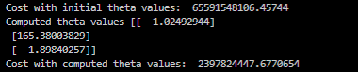

Theta 0:

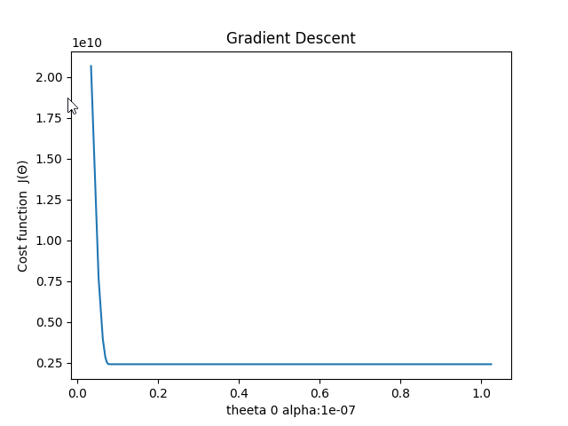

Theta 1:

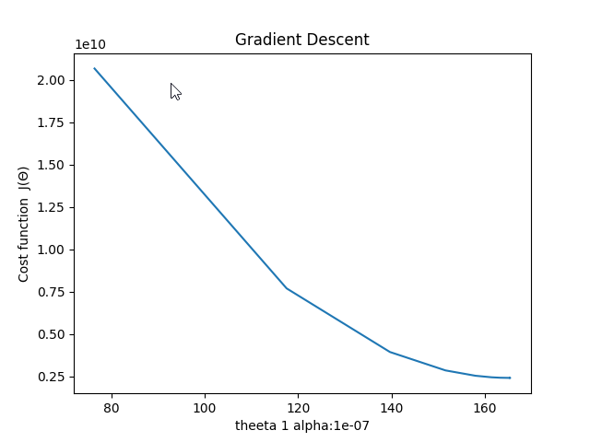

Theta 2:

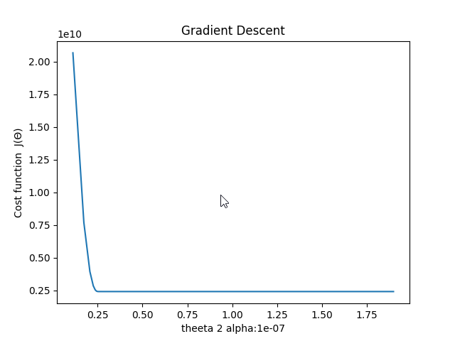

**Specifications:**

With normalization

alpha = 0.01

iterations = 10000

initial_theta = [[0],[0],[0]]

**Output:**

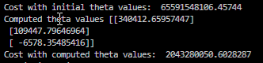

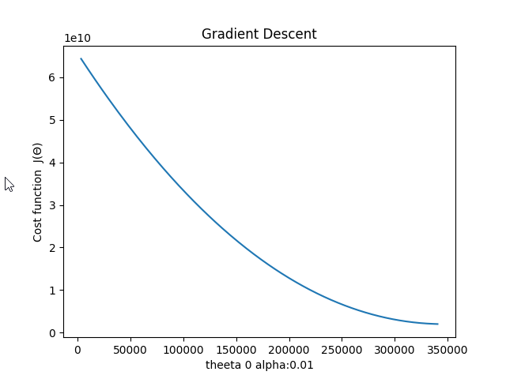

Theta 1:

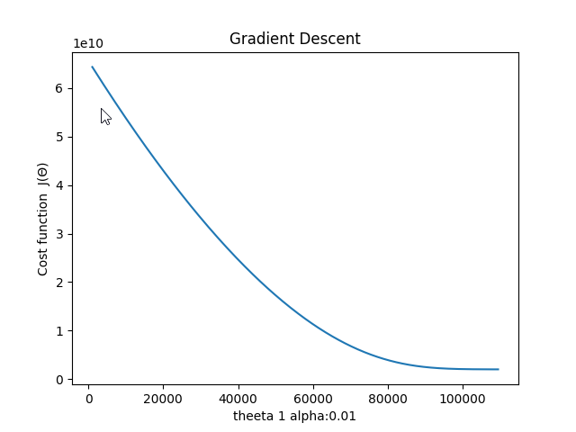

Theta 2:

